Hash functions II: Key derivations, protecting passwords, Merkle trees
Boaz Barak
Disclaimer: The MS-Word version of this text has significant formatting issues compared to the PDF and HTML versions.

Key derivation, protecting passwords, slow hashes, Merkle trees
Last lecture we saw the notion of cryptographic hash functions which are functions that behave like a random function, even in settings (unlike that of standard PRFs) where the adversary has access to the key that allows them to evaluate the hash function. Hash functions have found a variety of uses in cryptography, and in this lecture we survey some of their other applications. In some of these cases, we only need the relatively mild and well-defined property of collision resistance while in others we only know how to analyze security under the stronger (and not precisely well defined) random oracle heuristic.

Keys from passwords
We have seen great cryptographic tools, including PRFs, MACs, and CCA secure encryptions, that Alice and Bob can use when they share a cryptographic key of 128 bits or so. But unfortunately, many of the current users of cryptography are humans which, generally speaking, have extremely faulty memory capacity for storing large numbers. There are ${62}^{8}≈2^{48}$ ways to select a password of 8 upper and lower case letters + numbers, but some letter/numbers combinations end up being chosen much more frequently than others. Due to several large scale hacks, very large databases of passwords have been made public, and one estimate is that 91 percent of the passwords chosen by users are contained in a list of about $1,000≈2^{10}$ strings.
If we choose a password at random from some set $D$ then the entropy of the password is simply ${\text{log}}_{2}|D|$. However, estimating the entropy of real life passwords is rather difficult. For example, suppose that I use the winning Massachussets Mega-Lottery numbers as my password. A priori, my password consists of $5$ numbers between $1$ till $75$ and so its entropy is ${\text{log}}_{2}({75}^{5})≈31$. However, if an attacker knew that I did this, the entropy might be something like $\text{log}(520)≈9$ (since there were only 520 such numbers selected in the last 10 years). Moreover, if they knew exactly what draw I based my password on, then they would know it exactly and hence the entropy (from their point of view) would be zero. This is worthwhile to emphasize:
The entropy of a secret is always measured with respect to the attacker’s point of view.
The exact security of passwords is of course a matter of intense practical interest, but we will simply model the password as being chosen at random from some set $D⊆\{0,1\}^{n}$ (which is sometimes called the “dictionary”). The set $D$ is known to the attacker, but she has no information on the particular choice of the password.
Much of the challenge for using passwords securely relies on the distinction between offline and online attacks. If each guess for a password requires interacting online with a server, as is the case when typing a PIN number in the ATM, then even a weak password (such as a 4 digit PIN that at best provides $13$ bits of entropy) can yield meaningful security guarantees, as typically an alarm would be raised after five or so failed attempts.
However, if the adversary has the ability to check offline whether a password is correct then the number of guesses they can try can be as high as the number of computing cycles at their disposal, which can easily run into the billions and so break passwords of $30$ or more bits of entropy. (This is an issue we’ll return to after we learn about public key cryptography when we’ll talk about password authenticated key exchange.)
Consider a password manager application. In such an application, a user typically chooses a master password $p_{master}$ which she can then use to access all her other passwords $p_{1},…,p_{t}$. To enable her to do so without requiring online access to a server, the master password $p_{master}$ is used to encrypt the other passwords. However to do that, we need to derive a key $k_{master}$ from the password.

A natural approach is to simply let the key be the password. For example, if the password $p$ is a string of at most 16 bytes, then we can simply treat it as a $128$ bit key and use it for encryption. Stop and think why this would not be a good idea. In particular think of an example of a secure encryption $(E,D)$ and a distribution $P$ over $\{0,1\}^{n}$ of entropy at least $n/2$ such that if the key $k$ is chosen at random from $P$ then the encryption will be completely insecure.
A classical approach is to simply use a cryptographic hash function $H:\{0,1\}^{*}→\{0,1\}^{n}$, and let $k_{master}=H(p_{master})$. If we think of $H$ as a random oracle and $p_{master}$ as chosen randomly from $D$, then as long as an attacker makes $≪|D|$ queries to the oracle, they are unlikely to make the query $p_{master}$ and hence the value $k_{master}$ will be completely random from their point of view.
However, since $|D|$ is not too large, it might not be so hard to perform such $|D|$ queries. For this reason, people typically use a deliberately slow hash function as a key derivation function. The rationale is that the honest user only needs to evaluate $H$ once, and so could afford for it to take a while, while the adversary would need to evaluate it $|D|$ times. For example, if $|D|$ is about $100,000$ and the honest user is willing to spend 1 cent of computation resources every time they need to derive $k_{master}$ from $p_{master}$, then we could set $H(⋅)$ so that it costs 1 cent to evaluate it and hence on average it will cost the adversary $1,000$ dollars to recover it.
There are several approaches for trying to make $H$ deliberately “slow” or “costly” to evaluate but the most popular and simplest one is to simply let $H$ be obtained by iterating many times a basic hash function such as SHA-256. That is, $H(x)=h(h(h(⋯h(x))))$ where $h$ is some standard (“fast”) cryptographic hash function and the number of iterations is tailored to be the largest one that the honest users can tolerate.
In fact, typically we will set $k_{master}=H(p_{master}∥r)$ where $r$ is a long random but public string known as a “salt” (see saltfig). Including such a “salt” can be important to foiling an adversary’s attempts to amortize the computation costs, see the exercises.
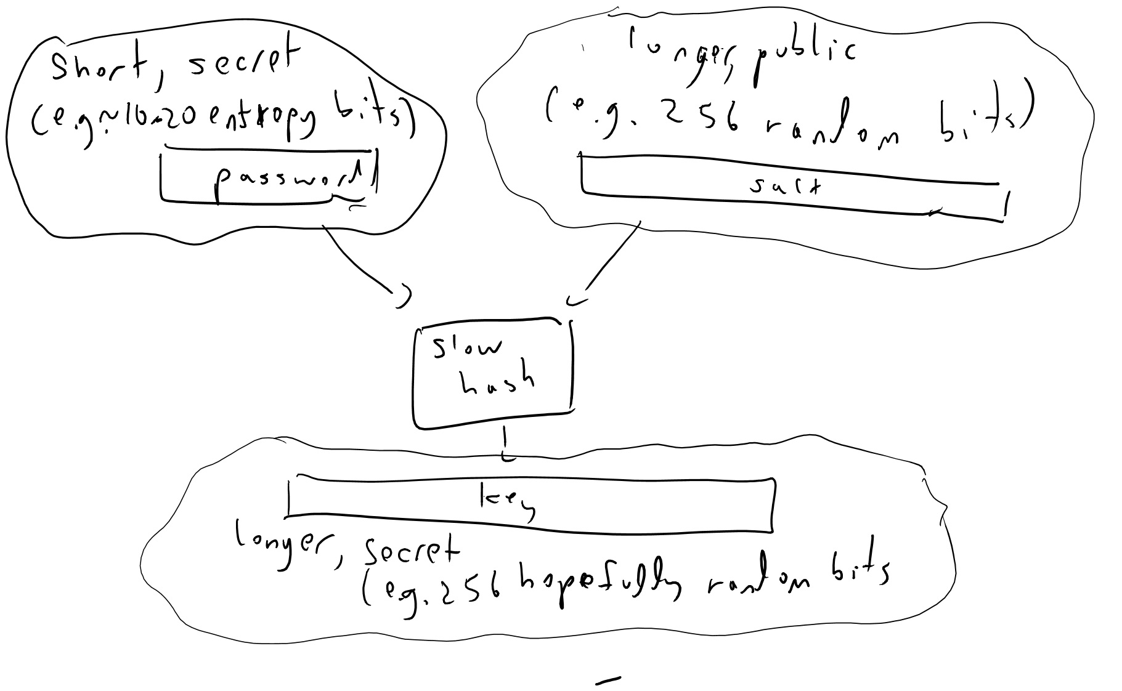
To obtain a key from a password we will typically use a “slow” hash function to map the password and a unique-to-user public “salt” value to a cryptographic key. Even with such a procedure, the resulting key cannot be considered as secure and unpredictable as a key that was chosen truly at random, especially if we are in a setting where an adversary can launch an offline attack to guess all possibilities.
Even when we don’t use one password to encrypt others, it is generally considered the best practice to never store a password in the clear but always in this “slow hashed and salted” form, so if the passwords file falls to the hands of an adversary it will be expensive to recover them.

Merkle trees and verifying storage.
Suppose that you outsource to the cloud storing your huge data file $x∈\{0,1\}^{N}$. You now need the $i^{th}$ bit of that file and ask the cloud for $x_{i}$. How can you tell that you actually received the correct bit?
Ralph Merkle came up in 1979 with a clever solution, which is known as “Merkle hash trees”. The idea is the following (see merkletreefig): suppose we have a collision-resistant hash function $h:\{0,1\}^{2n}→\{0,1\}^{n}$, and think of the string $x$ as composed of $t$ blocks of size $n$. We then hash every pair of consecutive blocks to transform $x$ into a string $x_{1}$ of $t/2$ blocks, and continue in this way for $\text{log}t$ steps until we get a single block $y∈\{0,1\}^{n}$. (Assume here $t$ is a power of two for simplicity, though it doesn’t make much difference.)
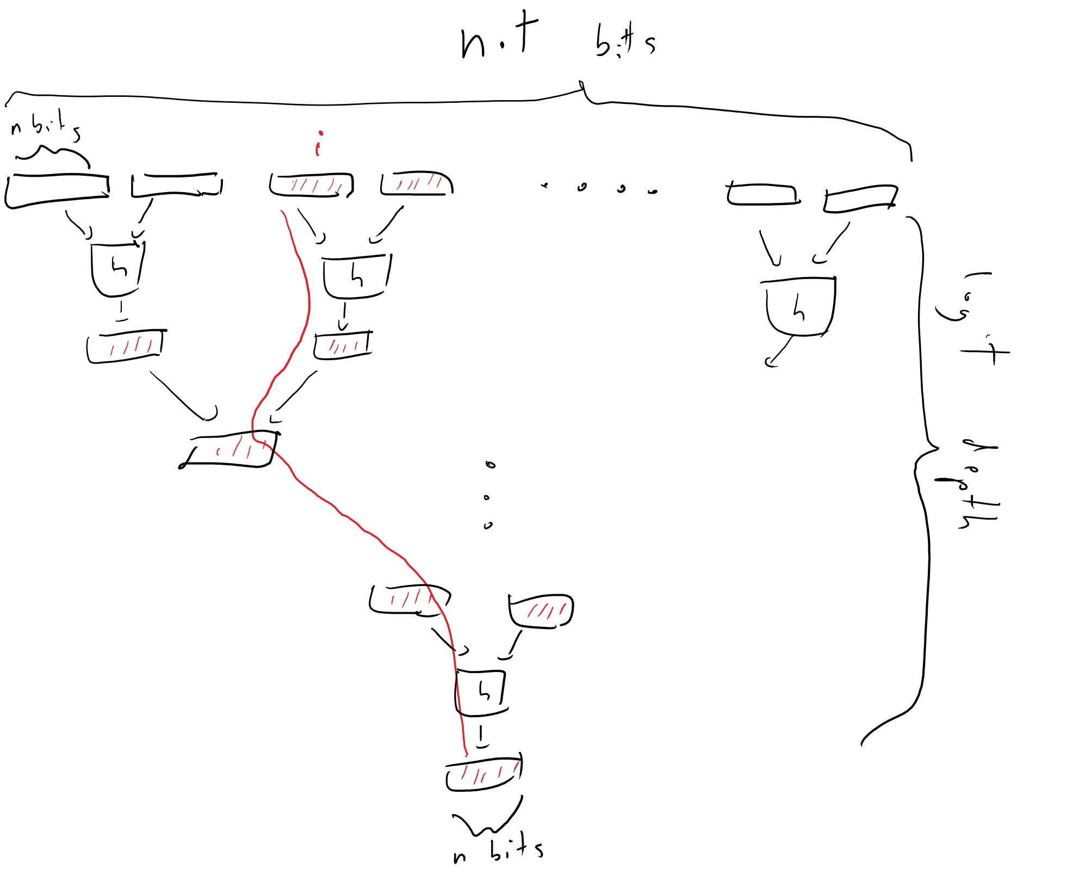
In the Merkle Tree construction we map a long string $x$ into a block $y∈\{0,1\}^{n}$ that is a “digest” of the long string $x$. As in a collision resistant hash we can imagine that this map is “one to one” in the sense that it won’t be possible to find $x′≠x$ with the same digest. Moreover, we can efficiently certify that a certain bit of $x$ is equal to some value without sending out all of $x$ but rather the $\text{log}t$ blocks that are on the path between $i$ to the root together with their “siblings” used in the hash function, for a total of at most $2\text{log}t$ blocks.
Alice, who sends $x$ to the cloud Bob, will keep the short block $y$. Whenever Alice queries the value $i$ she will ask for a certificate that $x_{i}$ is indeed the right value. This certificate will consists of the block that contains $i$, as well as all of the $2\text{log}t$ blocks that were used in the hash from this block to the root. The security of this scheme follows from the following simple theorem:

Suppose that $π$ is a valid certificate that $x_{i}=b$, then either this statement is true, or one can efficiently extract from $π$ and $x$ two inputs $z≠z′$ in $\{0,1\}^{2n}$ such that $h(z)=h(z′)$.

The certificate $π$ consists of a sequence of $\text{log}t$ pairs of size-$n$ blocks that are obtained by following the path on the tree from the $i^{th}$ coordinate of $x$ to the final root $y$. The last pair of blocks is the a preimage of $y$ under $h$, while each pair on this list is a preimage of one of the blocks in the next pair. If $x_{i}≠b$, then the first pair of blocks cannot be identical to the pair of blocks of $x$ that contains the $i^{th}$ coordinate. However, since we know the final root $y$ is identical, if we compare the corresponding path in $x$ to $π$, we will see that at some point there must be an input $z$ in the path from $x$ and a distinct input $z′$ in $π$ that hash to the same output.

Proofs of Retrievability
The above provides a way to ensure Alice that the value retrieved from a cloud storage is correct, but how can Alice be sure that the cloud server still stores the values that she did not ask about?
A priori, you might think that she obviously can’t. If Bob is lazy, or short on storage, he could decide to store only some small fraction of $x$ that he thinks Alice is more likely to query for. As long as Bob wasn’t unlucky and Alice doesn’t ask these queries, then it seems Bob could get away with this. In a proof of retrievability, first proposed by Juels and Kalisky in 2007, Alice would be able to get convinced that Bob does in fact store her data.
First, note that Alice can guarantee that Bob stores at least 99 percent of her data, by periodically asking him to provide answers (with proofs!) of the value of $x$ at 100 or so random locations. The idea is that if Bob dropped more than 1 percent of the bits, then he’d be very likely to be caught “red handed” and get a question from Alice about a location he did not retain.
Now, if we used some redundancy to store $x$ such as the RAID format, where it is composed of some small number $c$ parts and we can recover any bit of the original data as long as at most one of the parts were lost, then we might hope that even if 1% of $x$ was in fact lost by Bob, we could still recover the whole string. This is not a fool-proof guarantee since it could possibly be that the data lost by Bob was not confined to a single part. To handle this case one needs to consider generalizations of RAID known as “local reconstruction codes” or “locally decodable codes”. The paper by Dodis, Vadhan and Wichs is a good source for this; see also these slides by Seny Kamara for a more recent overview of the theory and implementations.

Entropy extraction
As we’ve seen time and again, randomness is crucial to cryptography. But how do we get these random bits we need? If we only have a small number $n$ of random bits (e.g., $n=128$ or so) then we can expand them to as large a number as we want using a pseudorandom generator, but where do we get those initial $n$ bits from?
The approach used in practice is known as “harvesting entropy”. The idea is that we make great many measurements $x_{1},…,x_{m}$ of events that are considered “unpredictable” to some extent, including mouse movements, hard-disk and network latency, sources of noise etc… and accumulate them in an entropy “pool” which would simply be some memory array. When we estimate that we have accumulated more than $128$ bits of randomness, then we hash this array into a $128$ bit string which we’ll use as a seed for a pseudorandom generator (see entropyextfig). Because entropy needs to be measured from the point of view of the attacker, this “entropy estimation” routine is a bit of a “black art” and there isn’t a very principled way to perform it. In practice people try to be very conservative (e.g., assume that there is only one bit of entropy for 64 bits of measurements or so) and hope for the best, which often works but sometimes also spectacularly fails, especially in embedded systems that do not have access to many of these sources.
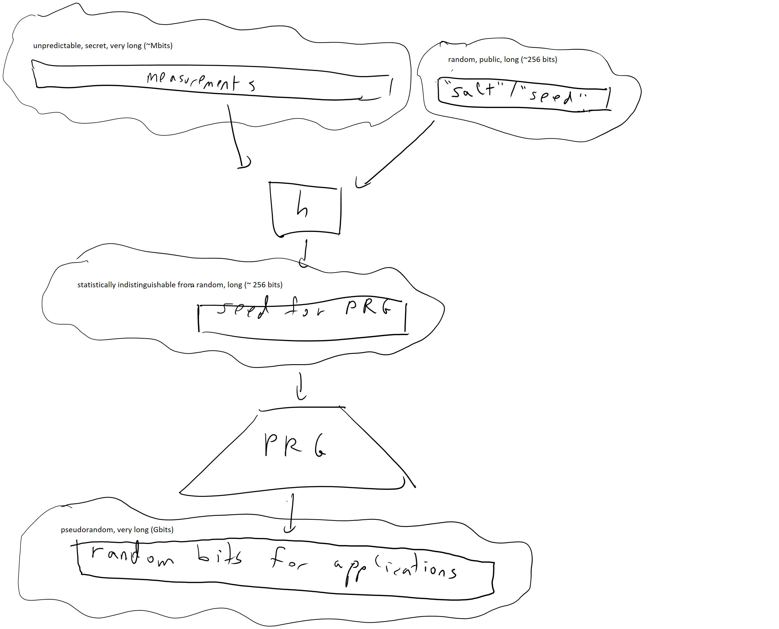
To obtain pseudorandom bits for cryptographic applications we hash down measurements which contain some entropy in them to a shorter string that is hopefully truly uniformly random or at least statistically close to it, and then expand this to get as many pseudorandom bits as we need using a pseudorandom generator.
How do hash functions figure into this? The idea is that if an input $x$ has $n$ bits of entropy then $h(x)$ would still have the same bits of entropy, as long as its output is larger than $n$. In practice people use the notion of “entropy” in a rather loose sense, but we will try to be more precise below.
The entropy of a distribution $D$ is meant to capture the amount of “uncertainty” you have over the distribution. The canonical example is when $D$ is the uniform distribution over $\{0,1\}^{n}$, in which case it has $n$ bits of entropy. If you learn a single bit of $D$ then you reduce the entropy by one bit. For example, if you learn that the ${17}^{th}$ bit is equal to $0$, then the new conditional distribution $D′$ is the uniform distribution over all strings in $x∈\{0,1\}^{n}$ such that $x_{17}=0$ and has $n−1$ bits of entropy. Entropy is invariant under permutations of the sample space, and only depends on the vector of probabilities, and thus for every set $S$ all notions of entropy will give ${\text{log}}_{2}|S|$ bits of entropy for the uniform distribution over $S$. A distribution that is uniform over some set $S$ is known as a flat distribution.
Where different notions of entropy begin to differ is when the distributions are not flat. The Shannon entropy follows the principle that “original uncertainty = knowledge learned + new uncertainty”. That is, it obeys the chain rule which is that if a random variable $(X,Y)$ has $n$ bits of entropy, and $X$ has $k$ bits of entropy, then after learning $X$ on average $Y$ will have $n−k$ bits of entropy. That is,
$H_{Shannon}(X)+H_{Shannon}(Y|X)=H_{Shannon}(X,Y)$
Where the entropy of a conditional distribution $Y|X$ is simply $E_{x←X}H_{Shannon}(Y|X=x)$ where $Y|X=x$ is the distribution on $Y$ obtained by conditioning on the event that $X=x$.
If $(p_{1},…,p_{m})$ is a vector of probabilities summing up to $1$ and let us assume they are rounded so that for every $i$, $p_{i}=k_{i}/2^{n}$ for some integer $k_{i}$. We can then split the set $\{0,1\}^{n}$ into $m$ disjoint sets $S_{1},…,S_{m}$ where $|S_{i}|=k_{i}$, and consider the probability distribution $(X,Y)$ where $Y$ is uniform over $\{0,1\}^{n}$, and $X$ is equal to $i$ whenever $Y∈S_{i}$. Therefore, by the principles above we know that $H_{Shannon}(X,Y)=n$ (since $X$ is completely determined by $Y$ and hence $(X,Y)$ is uniform over a set of $2^{n}$ elements), and $H(Y|X)=E\text{log}k_{i}$. Thus the chain rule tells us that $H_{Shannon}(X)=H(X,Y)−H(Y|X)=n−\sum_{i=1}^{m}{p_{i}}\text{log}(k_{i})=n−\sum_{i=1}^{m}{p_{i}}\text{log}(2^{n}p_{i})$ since $p_{i}=k_{i}/2^{n}$. Since $\text{log}(2^{n}p_{i})=n+\text{log}(p_{i})$ we see that this means that
HShannon(X)=n−i​pi⋅n−i​pilog(pi)=−i​pilog(pi)
using the fact that i​pi=1.
The Shannon entropy has many attractive properties, but it turns out that for cryptographic applications, the notion of min entropy is more appropriate. For a distribution $X$ the min-entropy is simply defined as $H_{∞}(X)={\text{min}}_{x}\text{log}(1/\text{Pr}[X=x])$. Note that if $X$ is flat then $H_{∞}(X)=H_{Shannon}(X)$ and that $H_{∞}(X)≤H_{Shannon}(X)$ for all $X$. We can now formally define the notion of an extractor:

A function $h:\{0,1\}^{ℓ+n}→\{0,1\}^{n}$ is a randomness extractor (“extractor” for short) if for every distribution $X$ over $\{0,1\}^{ℓ}$ with min entropy at least $2n$, if we pick $s$ to be a random “salt”, the distribution $h_{s}(X)$ is computationally indistinguishable from the uniform distribution.
The idea is that we apply the hash function to our measurements in $\{0,1\}^{ℓ}$ then if those measurements had at least $k$ bits of entropy (with some extra “security margin”) then the output $h_{s}(X)$ will be as good as random. Since the “salt” value $s$ is not secret, it can be chosen once at random and hardwired into the description of the function. (Indeed in practice people often do not explicitly use such a “salt”, but the hash function description contain some parameters IV that play a similar role.)

Suppose that $h:\{0,1\}^{ℓ+n}→\{0,1\}^{n}$ is chosen at random, and $ℓ<n^{100}$. Then with high probability $h$ is an extractor.

Let $h$ be chosen as above, and let $X$ be some distribution over $\{0,1\}^{ℓ}$ with ${\text{max}}_{x}\{\text{Pr}[X=x]\}≤2^{−2n}$. Now, for every $s∈\{0,1\}^{n}$ let $h_{s}$ be the function that maps $x∈\{0,1\}^{ℓ}$ to $h(s∥x)$, and let $Y_{s}=h_{s}(X)$. We want to prove that $Y_{s}$ is pseudorandom. We will use the following claim:
Claim: Let $Col(Y_{s})$ be the probability that two independent samples from $Y_{s}$ are identical. Then with probability at least $0.99$, $Col(Y_{s})<2^{−n}+100⋅2^{−2n}$.
Proof of claim: EsCol(Ys)=s​2−nx,x′​Pr[X=x]Pr[X=x′]y∈{0,1}n​Pr[h(s,x)=y]Pr[h(s,x′)=y]. Let’s separate this to the contribution when $x=x′$ and when they differ. The contribution from the first term is s​2−nx​Pr[X=x]2 which is simply $Col(X)=∑\text{Pr}[X=x]^{2}≤2^{−2n}$ since $\text{Pr}[X=x]≤2^{−2n}$. In the second term, the events that $h(s,x)=y$ and $h(s,x′)=y$ are independent, and hence the contribution here is at most x,x′​Pr[X=x]Pr[X=x′]2−n. The claim follows from Markov.
Now suppose that $T$ is some efficiently computable function from $\{0,1\}^{n}$ to $\{0,1\}$, then by Cauchy-Schwarz |E[T(Un)]−E[T(Ys)]|=|y∈{0,1}n​T(y)[2−n−Pr[Ys=y]]|≤y​T(y)2⋅y​(2−n−Pr[Ys=y])2 but opening up y​(2−n−Pr[YS=y])2 we get 2−n−2⋅2−ny​Pr[Ys=y]+y​Pr[Ys=y]2 or $Col(Y_{s})−2^{−n}$ which is at most the negligible quantity $100⋅2^{−2n}$.

This proof actually proves a much stronger statement. First, note that we did not at all use the fact that $T$ is efficiently computable and hence the distribution $h_{s}(X)$ will not be merely pseudorandom but actually statistically indistinguishable from truly random distribution. Second, we didn’t use the fact that $h$ is completely random but rather what we needed was merely pairwise independence: that for every $x≠x′$ and $y$, ${\text{Pr}}_{s}[h_{s}(x)=h_{s}(x′)=y]=2^{−2n}$. There are efficient constructions of functions $h(⋅)$ with this property, though in practice people still often use cryptographic hash function for this purpose.

Forward and backward secrecy
A cryptographic tool such as encryption is clearly insecure if the adversary learns the private key, and similarly the output of a pseudorandom generator is insecure if the adversary learns the seed. So, it might seem as if it’s “game over” once this happens. However, there is still some hope. For example, if the adversary learns it at time $t$ but didn’t know it before then, then one could hope that she does not learn the information that was exchanged up to time $t−1$. This property is known as “forward secrecy”. It had recently gained interest as means to protect against powerful “attackers” such as the NSA that may record the communication transcripts in the hope of deciphering them in some future after it had learned the secret key. In the context of pseudorandom generators, one could hope for both forward and backward secrecy. Forward secrecy means that the state of the generator is updated at every point in time in a way that learning the state at time $t$ does not help in recovering past state, and “backward secrecy” means that we can recover from the adversary knowing our internal state by updating the generator with fresh entropy. See this paper of me and Halevi for some discussions of this issue, as well as this later work by Dodis et al.

Since CPU speeds can vary quite radically and attackers might even use special-purpose hardware to evaluate iterated hash functions quickly, Abadi, Burrows, Manasse, and Wobber suggested in 2003 to use memory bound functions as an alternative approach, where these are functions $H(⋅)$ designed so that evaluating them will consume at least $T$ bits of memory for some large $T$. See also the followup paper of Dwork, Goldberg and Naor. This approach has also been used in some practical key derivation functions such as scrypt and Argon2.
The reason that people use entropy “pools” rather than simply adding the entropy to the generator’s state as it comes along is that the latter alternative might be insecure. Suppose that initial state of the generator was known to the adversary and now the entropy is “trickling in” one bit at a time while we continuously use the generator to produce outputs that can be observed by the adversary. Every time a new bit of entropy is added, the adversary now has uncertainty between two potential states of the generator, but once an output is produced this eliminates this uncertainty. In contrast, if we wait until we accumulate, say, 128 bits of entropy, then now the adversary will have $2^{128}$ possible state options to consider, and it could be computationally infeasible to cull them using further observation.
The notation $H_{∞}(⋅)$ for min entropy comes from the fact that one can define a family of entropy like functions, containing a function for every non-negative number $p$ based on the $p$-norm of the probability distribution. That is, the Rényi entropy of order $p$ is defined as Hp(X)=(1−p)−1−log(x​Pr[X=x]p). The min entropy can be thought of as the limit of $H_{p}$ when $p$ tends to infinity while the Shannon entropy is the limit as $p$ tends to $1$. The entropy $H_{2}(⋅)$ is related to the collision probability of $X$ and is often used as well. The min entropy is the smallest among all the entropies and hence it is the most conservative (and so appropriate for usage in cryptography). For flat sources, which are uniform over a certain subset, all entropies coincide.
The pseudorandomness literature studies the notion of extractors much more generally and consider all possible variations for parameters such as the entropy requirement, the salt (more commonly known as seed) size, the distance from uniformity, and more. The type of notion we consider here is known in that literature as a “strong seeded extractor”. See Vadhan’s monograph for an in-depth treatment of this topic.

